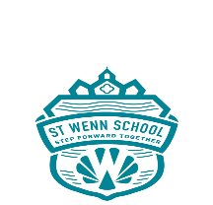 ST WENN SCHOOL
Agenda for the Full Governing Board of St Wenn School
Date: Tuesday 20th September 2022
Time: 5.30pm
Venue: St Wenn School

1. Welcome and introductions
2. Tour of school to see recent developments and classrooms
3. Revised School Development Plan
4. Ofsted report - Governor implications
5. Monitoring visits
6. Budget considerations
6.1 White boards
6.2 Increased costs eg energy
6.3 Increased costs for parents eg uniform, utilities
6.4 Pay award for staff
7. New Governor mentors
8. Governor roles and responsibilities
9. Subcommittee membership
10 Governor training needs and requirements
11. Website - Governor information/photos
12. Global uncertainty and curriculum implications
13. Inclusion, diversity and identity
14. Date of next meeting

