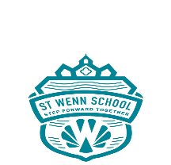 ST WENN SCHOOL
Agenda for Extraordinary Meeting of the Full Governing Board of St Wenn School
Date: Thursday, 12th November 2020
Time: 5.00pm
Venue: Virtual meeting using Microsoft Teams (remember to ‘blur’ background)

1. Welcome, Apologies and consideration of absence

2. Declaration of Business and Pecuniary Interest
2.1 To declare any interests for this meeting

3. To agree the minutes of informal meeting held 19.10.20

4. To agree the type of leadership for the school

5. To discuss and agree the process of recruitment and timeline
5.1 To agree the person specification
5.2 To agree the job description
5.3 To agree the Individual Pay Range (IPR)
5.4 To agree the job advertisement and closing date
5.5 To agree the type and format of information to send to potential applicants

6. To discuss and appoint the Selection Panel
6.1 To agree the date of shortlisting meeting for panel
6.2 To agree the date(s) of interview
6.3 To agree the assistance from County

7. Close meeting

8. Close Meeting

