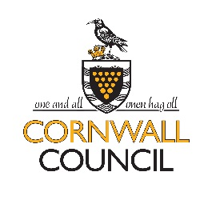
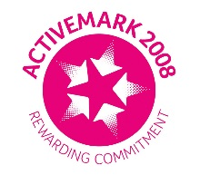
ST WENN, BODMIN, PL30 5PS
Headteacher Mrs S Berry
01726 890405
secretary@st-wenn.cornwall.sch.uk

Wednesday 22nd July 2020

To all the wonderful children of St Wenn school,

I just wanted to write to say how incredibly proud we all are of all of you. You have coped so well in these strange times and will go down in history as the ‘Corona Kids’!

I know that some of you may feel a little worried about returning in September. I want to let you know that all the adults in school have been working really hard to make sure that our school is a very safe place to come back to. We will also be working hard during the holiday to make sure that your classrooms are all ready for you and that we are all ready to welcome you back!

There will be a few changes but we will all be here to help and support you – we know it will be a little odd; we understand and promise that we will be very kind and patient. We will be sending you a short video just before you start back talking you through some of the things which will be the same…and some of the things which will be a little different.

We hope that you have a super summer holiday and can’t wait to see you in September.

Stay safe and stay smiling

Love from Mrs B x

