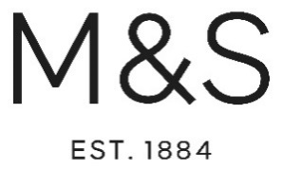

The purpose of this letter is to once again thank you for joining the Marks and Spencer Your School Uniform service and provide you with all the information that you need about how to order your uniform. We aim to provide the best service we can for you and hope that the information that is detailed below helps to make the process of buying school uniform easy.
Website

To log onto the website, simply go to the website listed below.
www.mandsyourschooluniform.com

This link will take you directly to the dedicated website and from here you can search for your school through
- Selecting your county
- Selecting your school from the list presented
Your dedicated school pages will display the items you have ordered with your school logo applied, as well as any other items that you have requested.
Once you have completed their transaction, a link will appear that will direct you to the main M&S Schoolwear site where you can separately shop for all core items such as trousers, shirts and skirts. Alternatively, they can shop our Plain section on our Homepage. (See more below)
Key Points About the Service

Listed below are some key points about the service.
- You can order online by visiting www.mandsyourschooluniform.com
- Or you can order by phone on 0333 014 8418 (9am-8pm Monday to Friday, 9am-4pm Saturday)
- M&S YSU is available for direct delivery to any UK address only. Customers cannot order, collect or return any of the Your School Uniform products at any M&S Store
- Standard UK delivery (3-5days) £3.50: express delivery £4.95. Express delivery is unavailable during August.
- All orders of £30 and above receive free standard delivery.
- All returns are free using a returns envelope and label provided. Items cannot be returned to M&S stores*
*Full T&Cs and details available at mandsyourschooluniform.co.uk

Customer Services Team
Should you wish to speak to anyone about your order or if you have any queries then you can contact our Customer Services Team directly either by the phone number or email below. This team will be able to assist you with all aspects of the service including ordering uniform, queries relating to returns and refunds as well as all other general enquiries.
Customer Services Team
Call: 0333 014 8418
Email: help@mandsyourschooluniform.com

Products ‘Not Available’ to buy – REGISTER INTEREST

Whilst we aim to have full availability of all your products throughout the back to school season, there may be times when some products may temporarily be out of stock. To ensure that we get products back on sale quickly we have developed our ‘Register Interest’ feature.
‘Register Interest’ appears when an item is out of stock. Parents are encouraged to input their email address in the box below as this will automatically trigger an instruction to us that a parent is waiting to buy this item. Once the product is back in stock, the parent will receive an email to alert then that the item they require is back on sale. Please see the illustration below. Please encourage your parents to use this feature if they need to as it really does work!

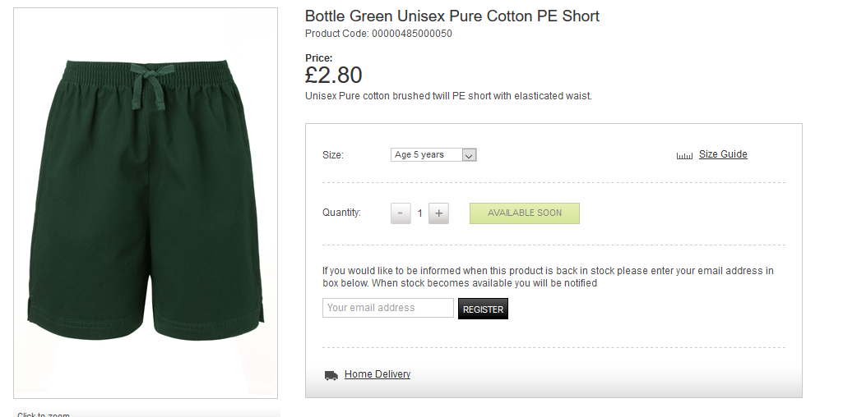

Plain Uniform

The ‘Plain Uniform’ section on the M&S Your School Uniform homepage is where we sell a range of our best-selling items such as trousers, skirts, jackets and shirts. This can be combined in the same basket as your school specific items.
Plain school uniform
Can’t find your school or would like to purchase additional plain items? Click the link below
Shop Plain Uniform

We hope that all this information provides both you and your parents with everything you need to use our service. We strive to deliver a service that is best in class and is of the standard you would expect from Marks and Spencer but if you have any feedback or suggestions about how we can improve our service further then please let us know.
With best wishes,

M&S Your School Uniform Team.

