Maths planning – Reception
Extension challenges in purple
Counting practice  Parent Tips:  *Practice counting forwards and backwards.  *Count sets and collections of objects and add or remove some by hiding objects under a cloth or in a bag. For example there was 10 teddies and now we are missing two how many do we have?  * Practice number formation whenever possible  *Practice writing number sentences | Counting:  Encourage counting backwards  Line up some plastic bottles (10) or more if you can and sing the song ‘ten green bottles’, each time knocking a bottle down.  https://video.search.yahoo.com/search/video?fr=mcafee&p=ten+green+bottles+song#action=view&id=2&vid=dec762783daa107a1005981f0005480c  (Challenge can you predict how many will be left when one is knocked down? Is there another object you could use making a new version of the song? How many are left if 2 bottles are knocked down?)  (Support use a number line to help support the order of numbers)  Songs  Sing a song which subtracts 2 each time, e.g. 10 fat sausages sizzling in a pan, one went pop and another went bang. 8 fat sausages… Children show fingers to match sausages.  There is an animated version of 10 Fat Sausages at www.bbc.co.uk.  .*number bonds are two numbers that make another number. Knowledge and recall of these bonds is helpful as they move up the school, do not worry though if they find this too hard.
Exploring and playing:  Playground  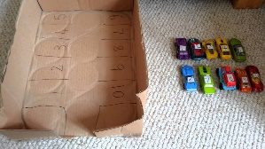  Parent talking tips:  - How many children/cars are in the playground/car park? How many will there be if 2 more join them?  - How many will there be if 1 goes home? | Counting on 1 more/1 less  Make a playground, farm, zoo or carpark. Discuss how many people, cars, animals there are. Begin to ask questions relating to:  How many will be left, if 1 or 2 arrive?  How many if 1 goes home?  How many if 2 animals go to the river?  Etc.  Support start with 1 more and 1 less and build up to bigger numbers  Challenge children to write as a number sentence using the – and = symbols.
Active Learning:  Teddy’s tea- time.  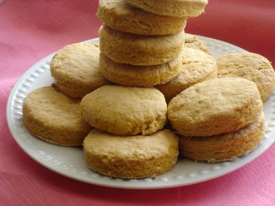  Parent talking tips:  - How many biscuits will we have left now?  - Can you show me the number on your number line? Can you write it down?  - What number is 1/2 less? | Number line  For this activity you will need some biscuits or another tea-time treat.  Start with a plate of 20 biscuits. Count them all together, then cover them with a tea towel.  Have a teddy give a biscuit to another teddy. How many will be left?  Point out 20 on the number line and 19 as the number before. Remove tea-towel to check there are 19 biscuits left.  Repeat, subtracting one biscuit, until there are none left, or teddy is full! Each time, cover the biscuits with the tea towel so children can’t count what’s left, but prompt them to count back one on the number line.  When you reach fewer than 11 biscuits, children should show the answer on their fingers.  Support children by starting with 10 biscuits and subtract 1 until there are no biscuits left.  Challenge children by taking away 2 biscuits (only when they are confident with 1 less) ask them to try and visualise the number line. Can you close your eyes and ‘see’ the number before?
Creating and thinking critically.  Up the ladder  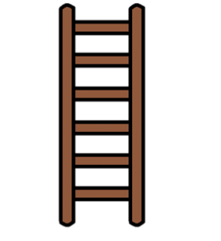  Parent talking tips:  - What number will you land on?  - Why do you think that?  - Let’s check if you are correct (demonstrate counting forwards/backwards?  - Which way do we need to move on the ladder?  - How many more spaces do you need to move to reach 20? | Counting on  *For this activity you will need a large sheet of paper for a ladder, some counters and some post it notes in a pot.*  Start by drawing a big ladder track with numbers from 1 to 20 in order in the spaces between the rungs. Each player puts a counter on 10 on the ladder.  Take it in turns to pick a post it note from the pot. The post-its will have +1, +2, +3, -1, -2, -3 on them. The player predicts where they will land on the ladder based on the post-it note that was picked.  If correct, they move their counter there. Make sure that they spot that some of the post-it have subtraction which means they will need to move down the ladder!  The first player to reach 20 wins.  Support children by using a 1-10 ladder, starting on 3, and using a dice with +1, +1 +2, +2, +2, -1.  Challenge children by asking them how many more to reach 20.
Other Maths learning  All of these activities are set as a guide for you to use if you have you own ideas please use them.  Try and focus the children’s attention on counting forwards on a number line for addition and counting backwards on a number line for subtraction.  Online maths games  https://www.topmarks.co.uk/ | Look on the link to explore lots of age appropriate maths games and challenges relating to subtraction.  https://www.topmarks.co.uk/subtraction/subtraction-to-10  https://www.starfall.com/h/addsub/addsub-ladder/?sn=math1--math0

Please note
‘Number sentence’ is the terminology we use at St Wenn to describe a written sum.

