**National Curriculum:**

Pupils should be taught to:

♣ recognise that light appears to travel in straight lines

♣ use the idea that light travels in straight lines to explain that objects are seen because they give out or reflect light into the eye

♣ explain that we see things because light travels from light sources to our eyes or from light sources to objects and then to our eyes

♣ use the idea that light travels in straight lines to explain why shadows have the same shape as the objects that cast them.

Working Scientifically:

planning different types of scientific enquiries to answer questions, including recognising and controlling variables where necessary

♣ taking measurements, using a range of scientific equipment, with increasing accuracy and precision, taking repeat readings when appropriate

♣ recording data and results of increasing complexity using scientific diagrams and labels, classification keys, tables, scatter graphs, bar and line graphs

♣ using test results to make predictions to set up further comparative and fair tests

♣ reporting and presenting findings from enquiries, including conclusions, causal relationships and explanations of and degree of trust in results, in oral and written forms such as displays and other presentations

♣ identifying scientific evidence that has been used to support or refute ideas or arguments

What will I know by the end of the unit?

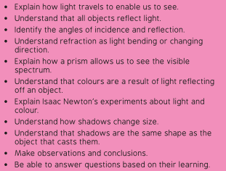

**What should I already know?**

Recognise that they need light in order to see things and that dark is the absence of light.

Notice that light is reflected from surfaces.

Recognise that light from the sun can be dangerous and that there are ways to protect their eyes. Recognise that shadows are formed when the light from a light source is blocked by an opaque object.

Find patterns in the way that the size of shadows change.

**Vocabulary:**

reflection

refraction

colour spectrum,

shadow theatre

light source

ray

prism

spectrum

transparent

translucent

opaque

**Learning Experiences:**

Making a model of how light travels

Creating a periscope and explaining how it works.

Investigate refraction by using water and light.

Investigating how a prism changes a ray of light

Investigating how we see colour.

Creating a shadow theatre.